where 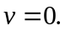
Papers written by Australian Maths Software

SEMESTER ONE

REVISION 3

MATHEMATICS METHODS
UNIT 3

2016

SOLUTIONS

SECTION ONE

1. (5 marks)
(a) 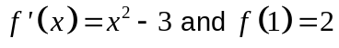
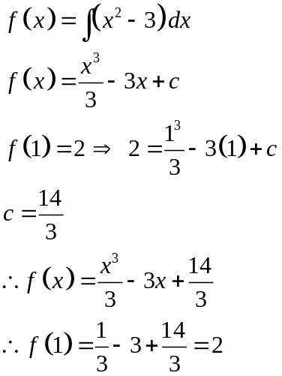
✓
✓
✓
(3)

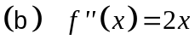
✓
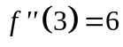
(1)

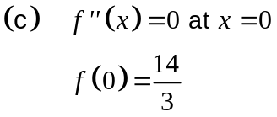
✓
(1)

2. (9 marks)
✓
(a) (i) 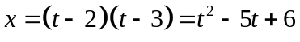
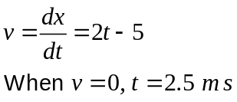
✓
✓
(3)
(ii) 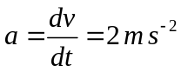
✓
The acceleration is always constant as the velocity is linear
✓

and the acceleration is the gradient function of the velocity.
The gradient of the 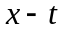 graph is always increasing so the
✓

acceleration is always positive. (3)
(b) Where 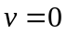 there is a turning point in the displacement graph. ✓
As the acceleration graph is positive () at that point, ✓
the turning point in the displacement graph is a minimum. ✓ (3)

3. (8 marks)
(a) (i) 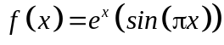
✓ ✓

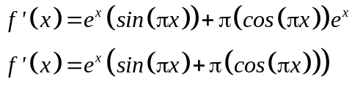 (2)

(ii) 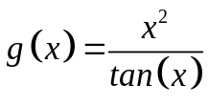
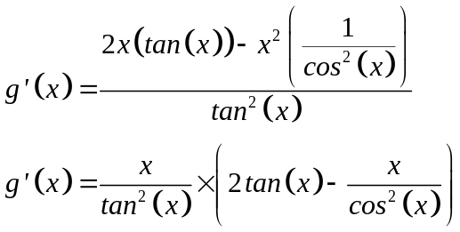
✓✓ -1/error

(2)
(b) ((i) 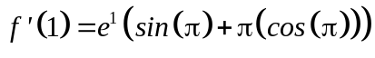
✓
✓
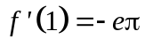 (2)

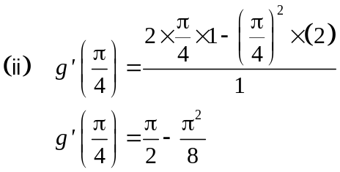 (2)
✓
✓
4. (6 marks)

(a) 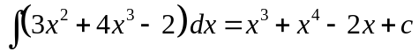 ✓ (1)
(b) (i) 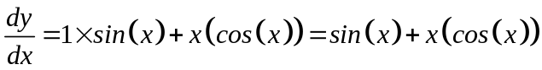 ✓✓ (1)

(ii) 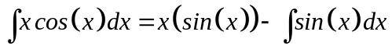 ✓ ✓
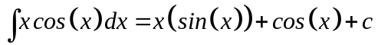 ✓ (3)

5. (7 marks)
(a) 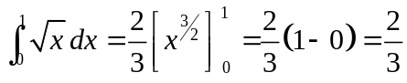
✓ ✓ (2)

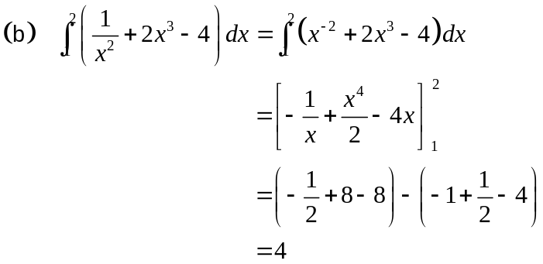
✓
✓
✓
(3)

(c) 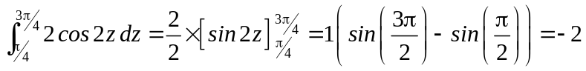 (3)
✓ ✓

6. (7 marks)
(a) (i) 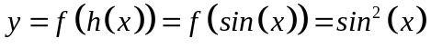 ✓ (1)
(ii) 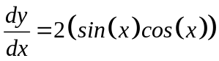 ✓
At 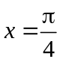 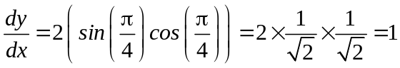 ✓ (2)

(b) (i) 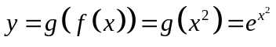 (2)
✓ ✓

(ii) 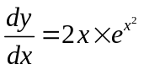 ✓
At 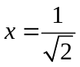, 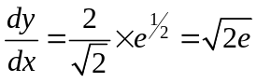 ✓ (2)

7. (7 marks)
(a) 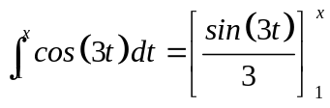 ✓
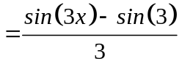 ✓ (2)

(b) 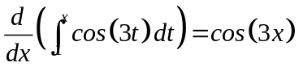 ✓✓ (2)

(c) 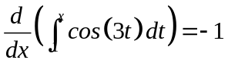
✓
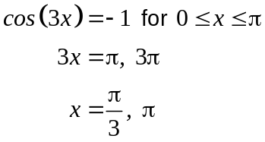
✓
✓
(3)

END OF SECTION ONE
SECTION TWO
8. (6 marks)
(a) 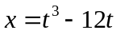
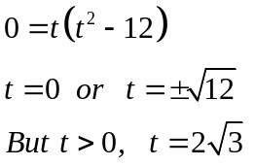
✓ ✓

(2)
(b) 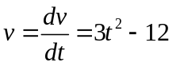 ✓
Changed direction when
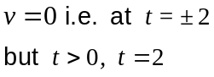
✓

(2)
(c) 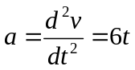
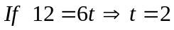 ✓
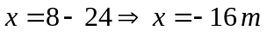 ✓ (2)

9. (9 marks)
(a) (i) 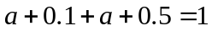
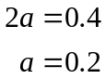 (1)
✓

(ii) 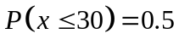 ✓ (1)

(iii) E(X) = Σxp(x)
E(X) = 10 × 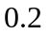 + 20 × 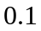 + 30 × + 40 ×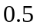
E(X) = 30 ✓

Var(X) = E(X²) – μ²
Var(X) =10² × + 20² × + 30² × + 40² × 30² ✓
Var(X) = 140 ✓
Sd(X) = 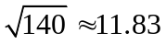 ✓ (4)

(b) (i) 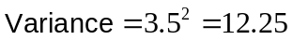 ✓ (1)

(ii) E(X) = 5 ✓
Sd(X) = 1.75 ✓ (2)

10. (4 marks)
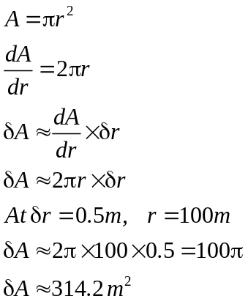
✓
✓
✓
✓

11. (8 marks)
(a) 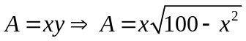 (2)
✓ ✓
(b) Maximum area when 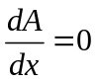
✓
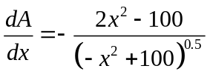
✓
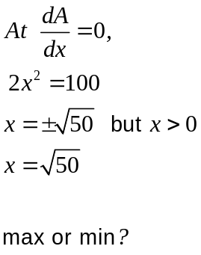
✓

0 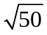 10
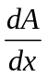 + 0
✓

Therefore max at 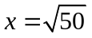

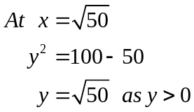
✓
✓
Therefore the maximum area occurs when 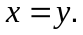 (6)
12. (7 marks)
(a) 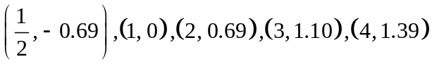 ✓✓✓✓-1/error (4)

(b)
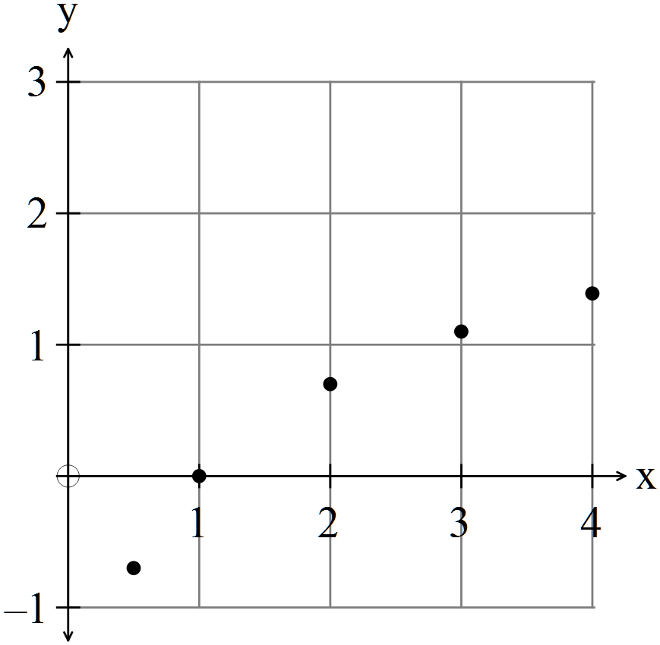 ✓✓
(2)
(c) 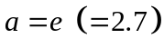 ✓ (1)

13. (5 marks)
(a) 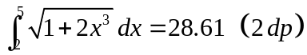 ✓✓ (2)

(b) (i) 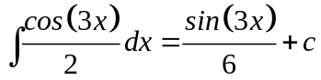 ✓

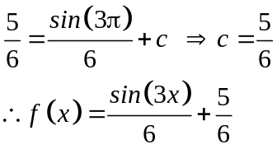
✓
(2)

(iii) 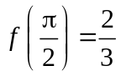 ✓ (1)

14. (14 marks
(a) (i) 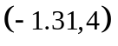and 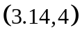 ✓ ✓ (2)
(ii) Area = 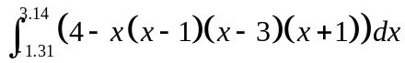 ✓✓ (2)
(iii) Area = 25.53 units² ✓✓ (2)

(b) (i) From below
✓
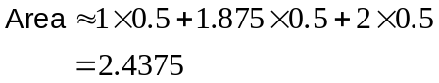
✓
(2)
(ii) From above
✓
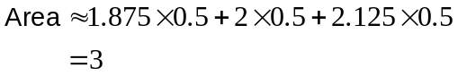 (2)
✓
(iii) The area calculated from below is an underestimate.
The area calculated from above is overestimate.
The average combines both the underestimate and the overestimate
and should be more accurate. ✓
Average is 2.71875
Area 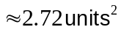 ✓ (2)

(iv) 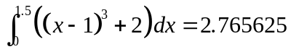 ✓
Difference from estimate is 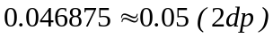 ✓ (2)
15. (9 marks)
(a) 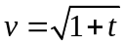
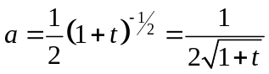 ✓
As ✓ (2)

(b) 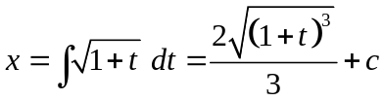 ✓
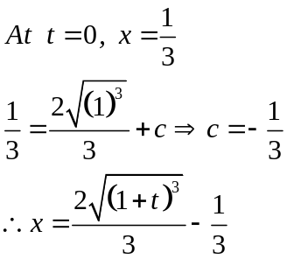
✓
(2)
(c) At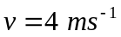, 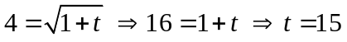
✓
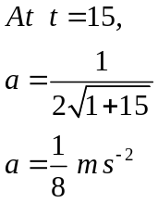
✓
(2)
(d) 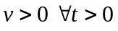 so toy does not change direction.
At 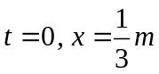 At 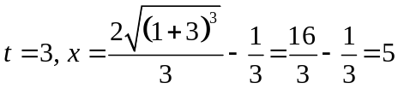
✓
✓
Therefore distance travelled is 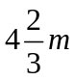 ✓ (3)
16. (8 marks)
(a) 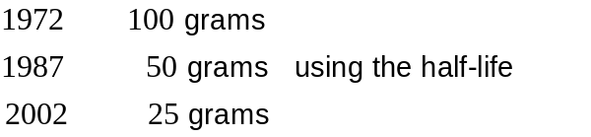

In 2002 there will be 25 grams of DDT left so it will take 30 years. ✓ (1)

(b) 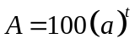
At 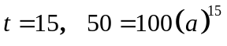 ✓
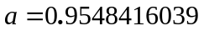 ✓ (2)

(c) ✓ (1)

(d) ✓ ✓ (2)
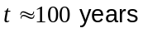 ✓

(e) 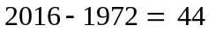years ✓
✓ (2)

17. (8 marks)
(a)
 | 0 | 1 | 2 | 3 | 4
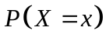 | 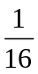 | 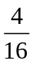 | 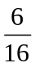
✓✓

(2)
(b) 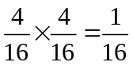 (2)
✓✓
(c) (i) 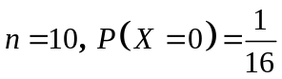 ✓
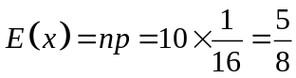 ✓
i.e. expect one family to have no boys. ✓ (3)

(ii) You cannot have a fraction of a family, so no, you would never get exactly that
number. ✓ (1)

18. (9 marks)

(a) 0.25 ✓✓ (2)
(b) 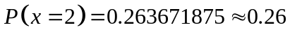 ✓✓ (2)
(c) 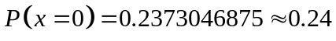 ✓✓ (2)
(d) 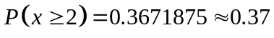 ✓✓ (2)
(e) 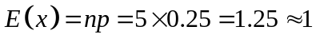 ✓ (1)
19. (8 marks)
(a)
 | 1 | 2 | 3 | 4
 | 0.1 | 0.2 | 0.4 | 0.3
✓✓
(2)
(b) 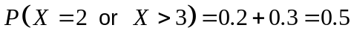 (2)
✓ ✓
(c) Yes, as the relative proportions could be estimated. ✓ (2)

(d) By inspection, about 3. ✓✓ (2)
20. (6 marks)
(a) 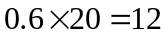
Peter will have to guess 8 questions. ✓ (1)

(b) 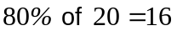 Needs to get 16 or more correct to get 80% ✓

Peter knows 12, so needs to get at least 4 more correct out of the 8 he has to guess. ✓

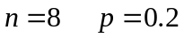
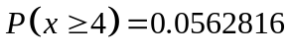 ✓✓ (4)

END OF SECTION TWO

